**Answer of Introduction of Analytics Mandatory**

1. **Which day had the maximum number of logins on the app?**



I used the max formula =MAX (C2:C101) to bring out the maximum login in the app.

Then I used the filter to choose 200 number.

After which it shows that on 6th January,2021 Wednesday the maximum number of logins on the app was 200.

1. **Which hour had the highest logins on Tuesday?**

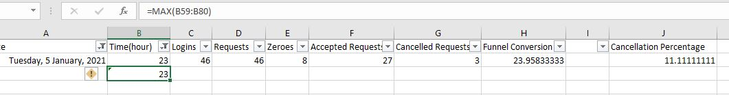

First, I use filter option to bring the data of Tuesday Only.

Then use the formula =MAX (B59:B80) to bring the highest login on Tuesday.

After which it shows it shows on Tuesday, 5th January,2021, 23 Hours has the highest login with 46 logins.

3. **"Top of the funnel conversion is defined as % of logged in users that requested a ride.**

**a) Which day had the highest top of the funnel conversion?**

Ans:

First, I make a new cell name Funnel Conversion which shows the value of conversion using formula =MAX(D2/$I$7*100).

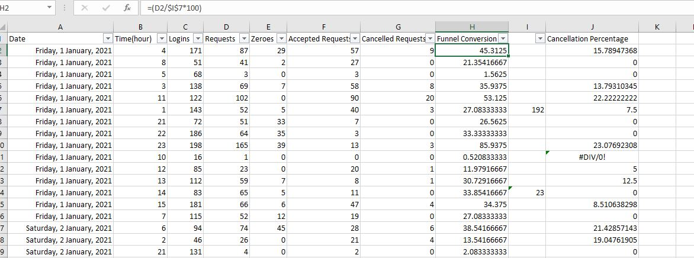

Then I used Filter Function which shows on Tuesday, 5th January,2021 has the highest final conversion with 100 value.



**b) Which hour on Tuesday had the lowest top of the funnel conversion"**

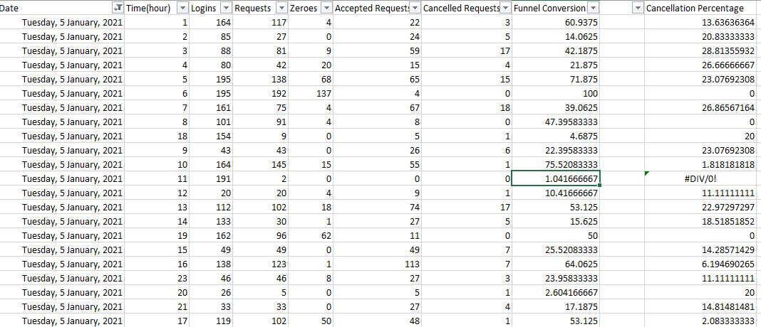

From the above image this shows that,

First I use filter option to bring the data of Tuesday then it gives a detail picture about the funnel conversion values.

Now from the below picture I used filter option of funnel conversion to choose the lowest values



Which shows Tuesday,5th January,2021 is the lowest top of the funnel conversion of 1.04166667 with 11 hour.

1. **"Users raise customer support tickets when they request a cab, but there are no cabs available. If you plot a curve of tickets/day, which day would have the maxima?"**

Ans : First, I used the filter function in Cancellation Request column to understand the highest cancellation trip on the app.



From the above clip it shows that on Thursday, 7th January,2021 had the maximum cancellation requests is 35.

I also make a scatter chart below which shows that 35 has the highest cancellation chart.

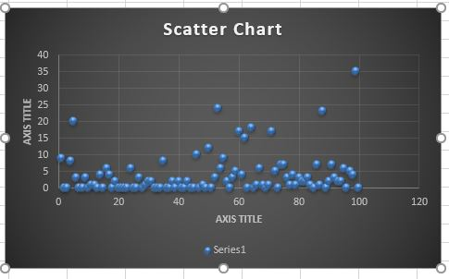

1. **"Cancellation percentage is defined as %of rides that are cancelled after being accepted by the drivers. If you calculate cancellation rates on the basis of aggregate data daily, what is the median?"**

Ans:

To calculate cancellation rates on the basis of aggregate daily basis is that,

Firstly, I calculate data with using cancellation request column to understand the overall performance of the dataset.

After which it used the median formula of =Median (G2:G101) which give the output of 2.

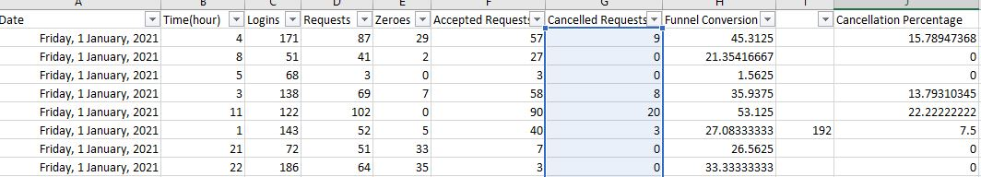



1. **What is the highest rating among the drivers who spent at least 50 hours on the app in the week?**

Ans: First I used the filter option in Hours Active column to generate the 50 hours and greater than 50 values in the dataset which has been showed in the below clip.

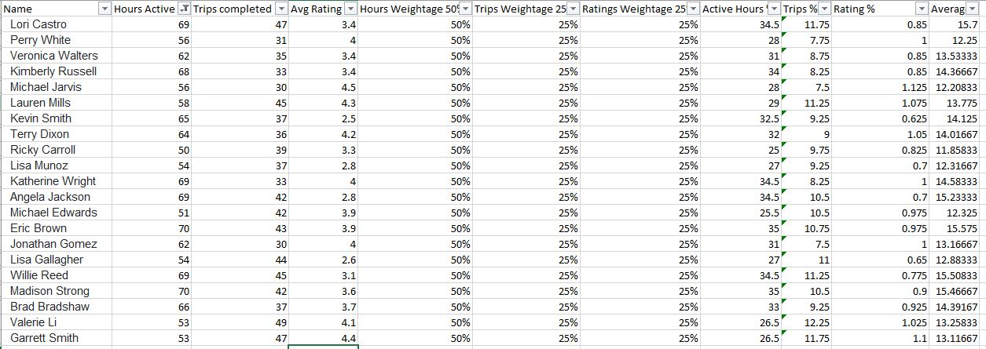

After this I used filter option in Avg Rating which shows that Michael Jarvis has the highest rating among the drivers who spent at least 50 hours on the app with 4.5 Avg Rating .



1. **The App assigns a score to each driver on the basis of 3 parameters - #hours active, #trips competed, and average rating. If 50% weightage is given to #hours active and other two parameters are given equal weightage, who are the top 3 drivers of the week.**

Ans: 

Hours weightage 50% column is the 50% of hours active column.

Trips weightage 25% column is the 25% of trips completed column.

Ratings weightage 25% column is the 25% of trips completed column.

Average column is the average of active hours, trips % and ratings % column.

I used filter in Average column to find the top 3 drivers of the week which gives:

Lori Castro 15.7

Eric Brown 15.575

Willie Reed 15.50833

1. **"The company measures demand supply ratio of the business by comparing #requests to #drivers on a weekly basis. What was the ratio of demand to supply for this week?"**

Ans :

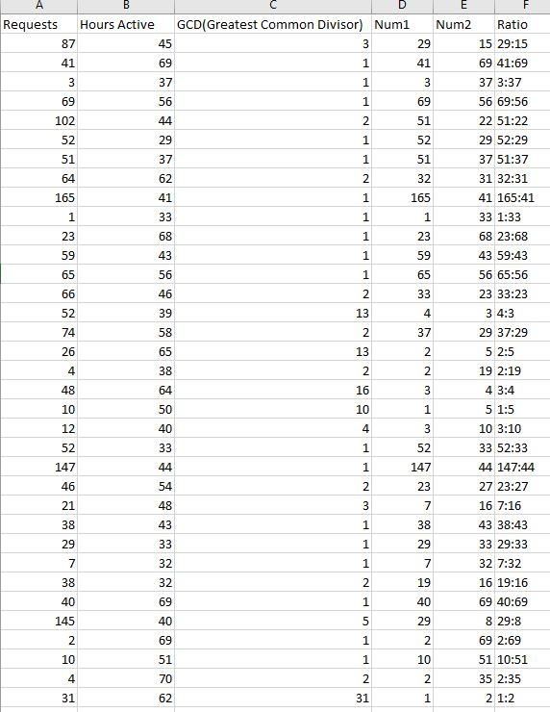

I used the GCD formula to find the common divisible value between Requests and Active hours, which is represented by GCD column[[=GCD(A2,B2)]].

Then I make num1 and num2 column which signify =A2/C2 and =B2/C2 respectively.

After which I make another column “Ratio” which signify concatenation formula =D2&":"&E2 to find the ratio of the dataset.

1. **"The company has decided to give incentives to the drivers to boost supply side of the business. There are two alternatives.**

**Option A: For every hour after the 50th hour, drivers get an additional Rs 10/hour. For every trip after 30th trip, drivers get an additional Rs 10/Trip.**

**Any driver with a rating of less than 3 would not be eligible for incentive.**

Ans Option A : 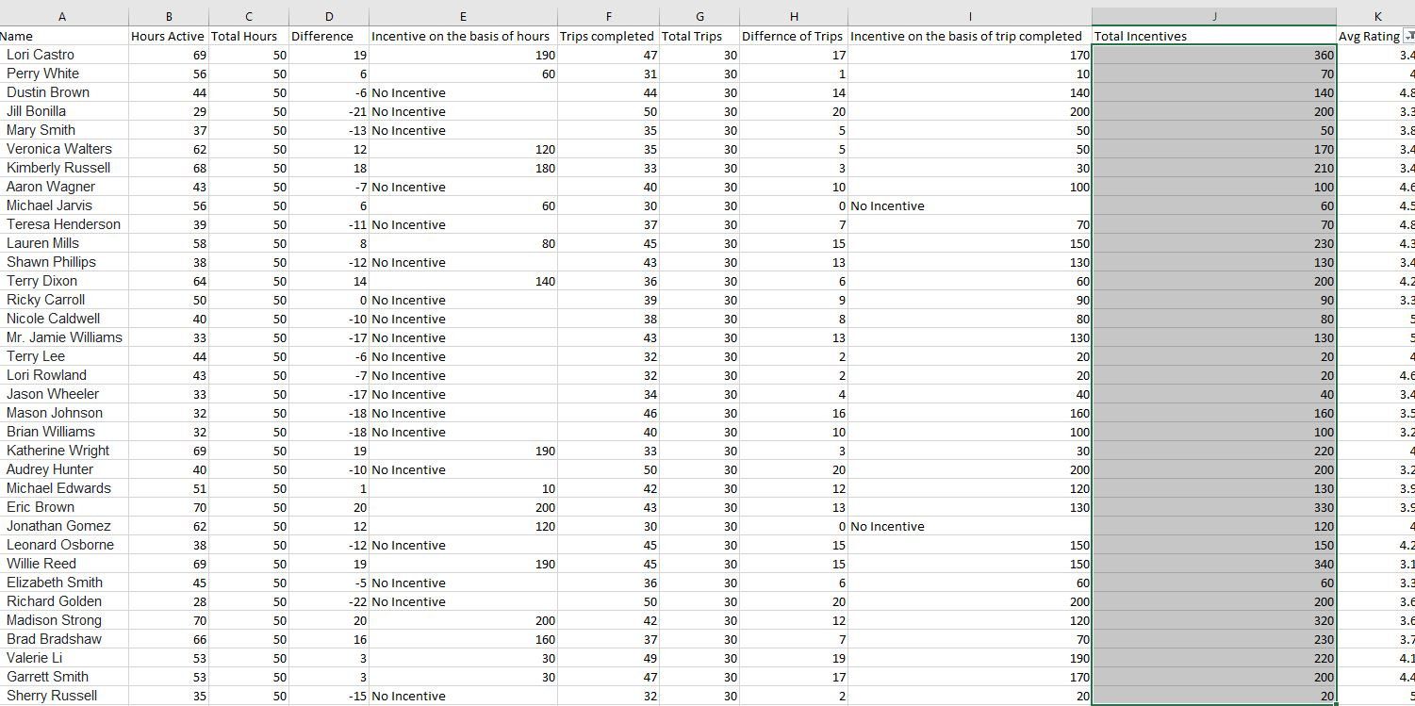

Difference column is the difference of Hours Active and Total hours by using the formula =B3-C3.

I have used this formula =IF(B3>C3,D3*10,”No Incentive”) to find Incentive on basis of hours.

Difference of trips column is the difference of Trips completed and total trips by using the formula =F3-G3.

I have used this formula =IF(F3>G3, H3*10, “No Incentive”) Incentives on the basis of trip completed.

Total Incentives column is a sum of incentive on the basis of trip completed and incentive on the basis of hour columns

I have use the Avg Rating column to find the rating greater than 3 by using the filter.

**Option B: For every hour after the 40th hour, drivers get an additional Rs 5/hour. For every trip after 40th trip, drivers get an additional Rs 20/Trip.**

**Any driver with a rating of less than 3 would not be eligible for incentive.**

Ans Option B:

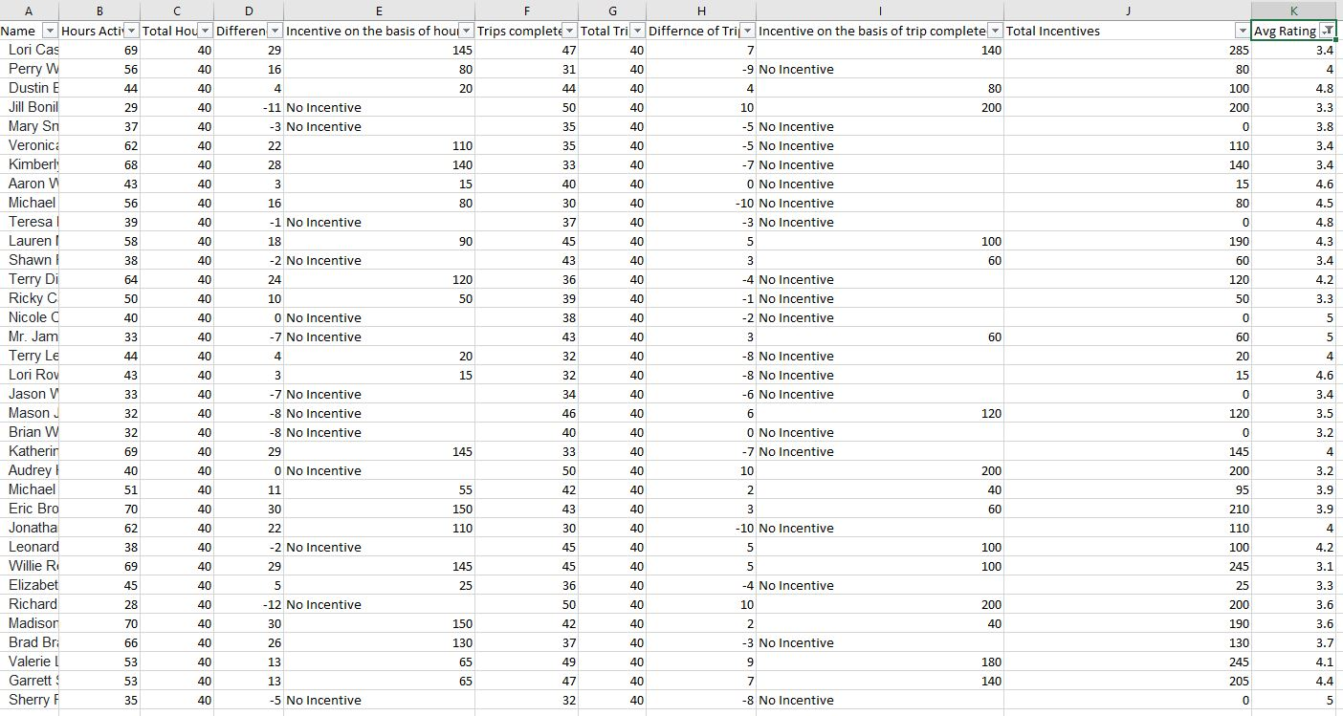

Difference column is the difference of Hours Active and Total hours by using the formula =B3-C3.

I have used this formula =IF(B3>C3,D3*5,”No Incentive”) to find Incentive on basis of hours.

Difference of trips column is the difference of Trips completed and total trips by using the formula =F3-G3.

I have used this formula =IF(F3>G3, H3*20, “No Incentive”) Incentives on the basis of trip completed.

Total Incentives column is a sum of incentive on the basis of trip completed and incentive on the basis of hour columns

I have use the Avg Rating column to find the rating greater than 3 by using the filter.